1. Delete the gallery as a separate page.
2. Add San Francisco Neighborhood Centers Together above the Richmond District Neighborhood Center address line.

3. Displays About Us main menu, and What We Do, Vision and Mission, and History sub menus.

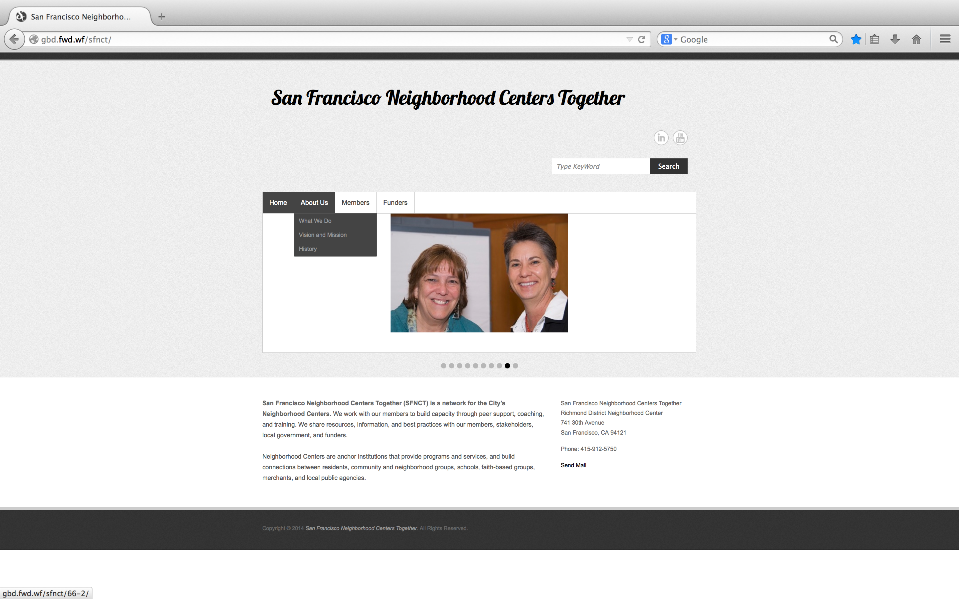

4. Select the About Us menu option will launch the About Us page.

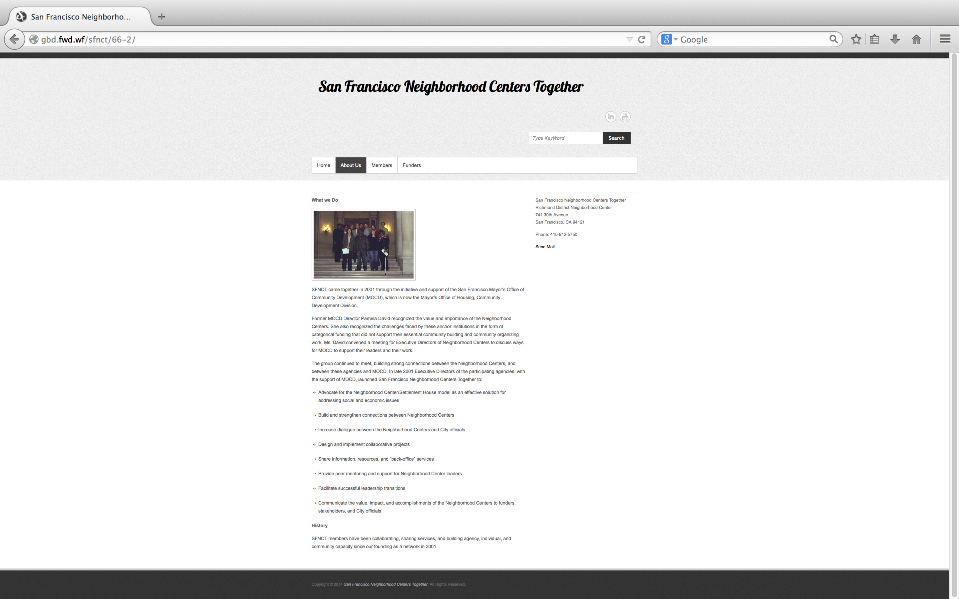

5. Select the What We Do sub menu option will launch the About Us page to the What We Do section on that page.

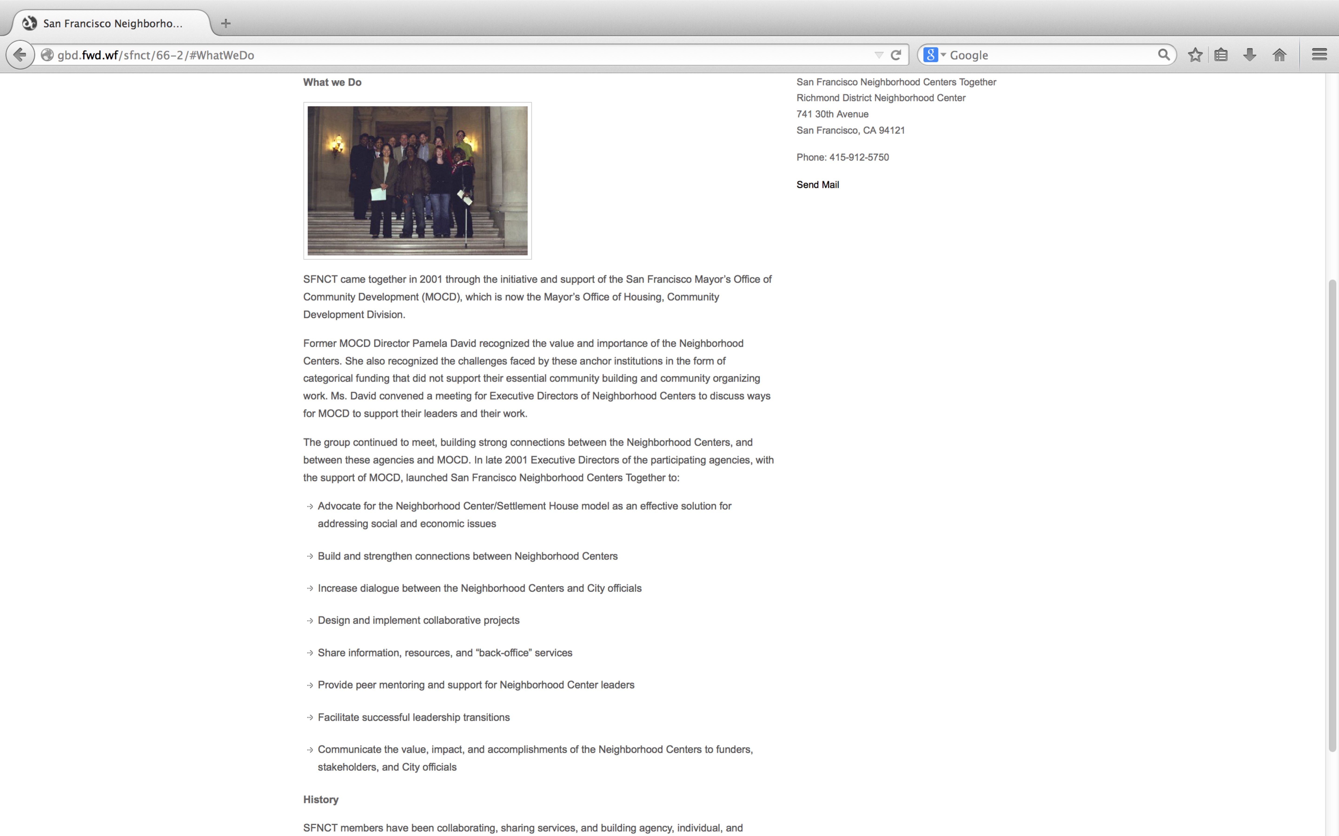

6. Select the Vision and Mission sub menu option will launch the Vision and Mission page.

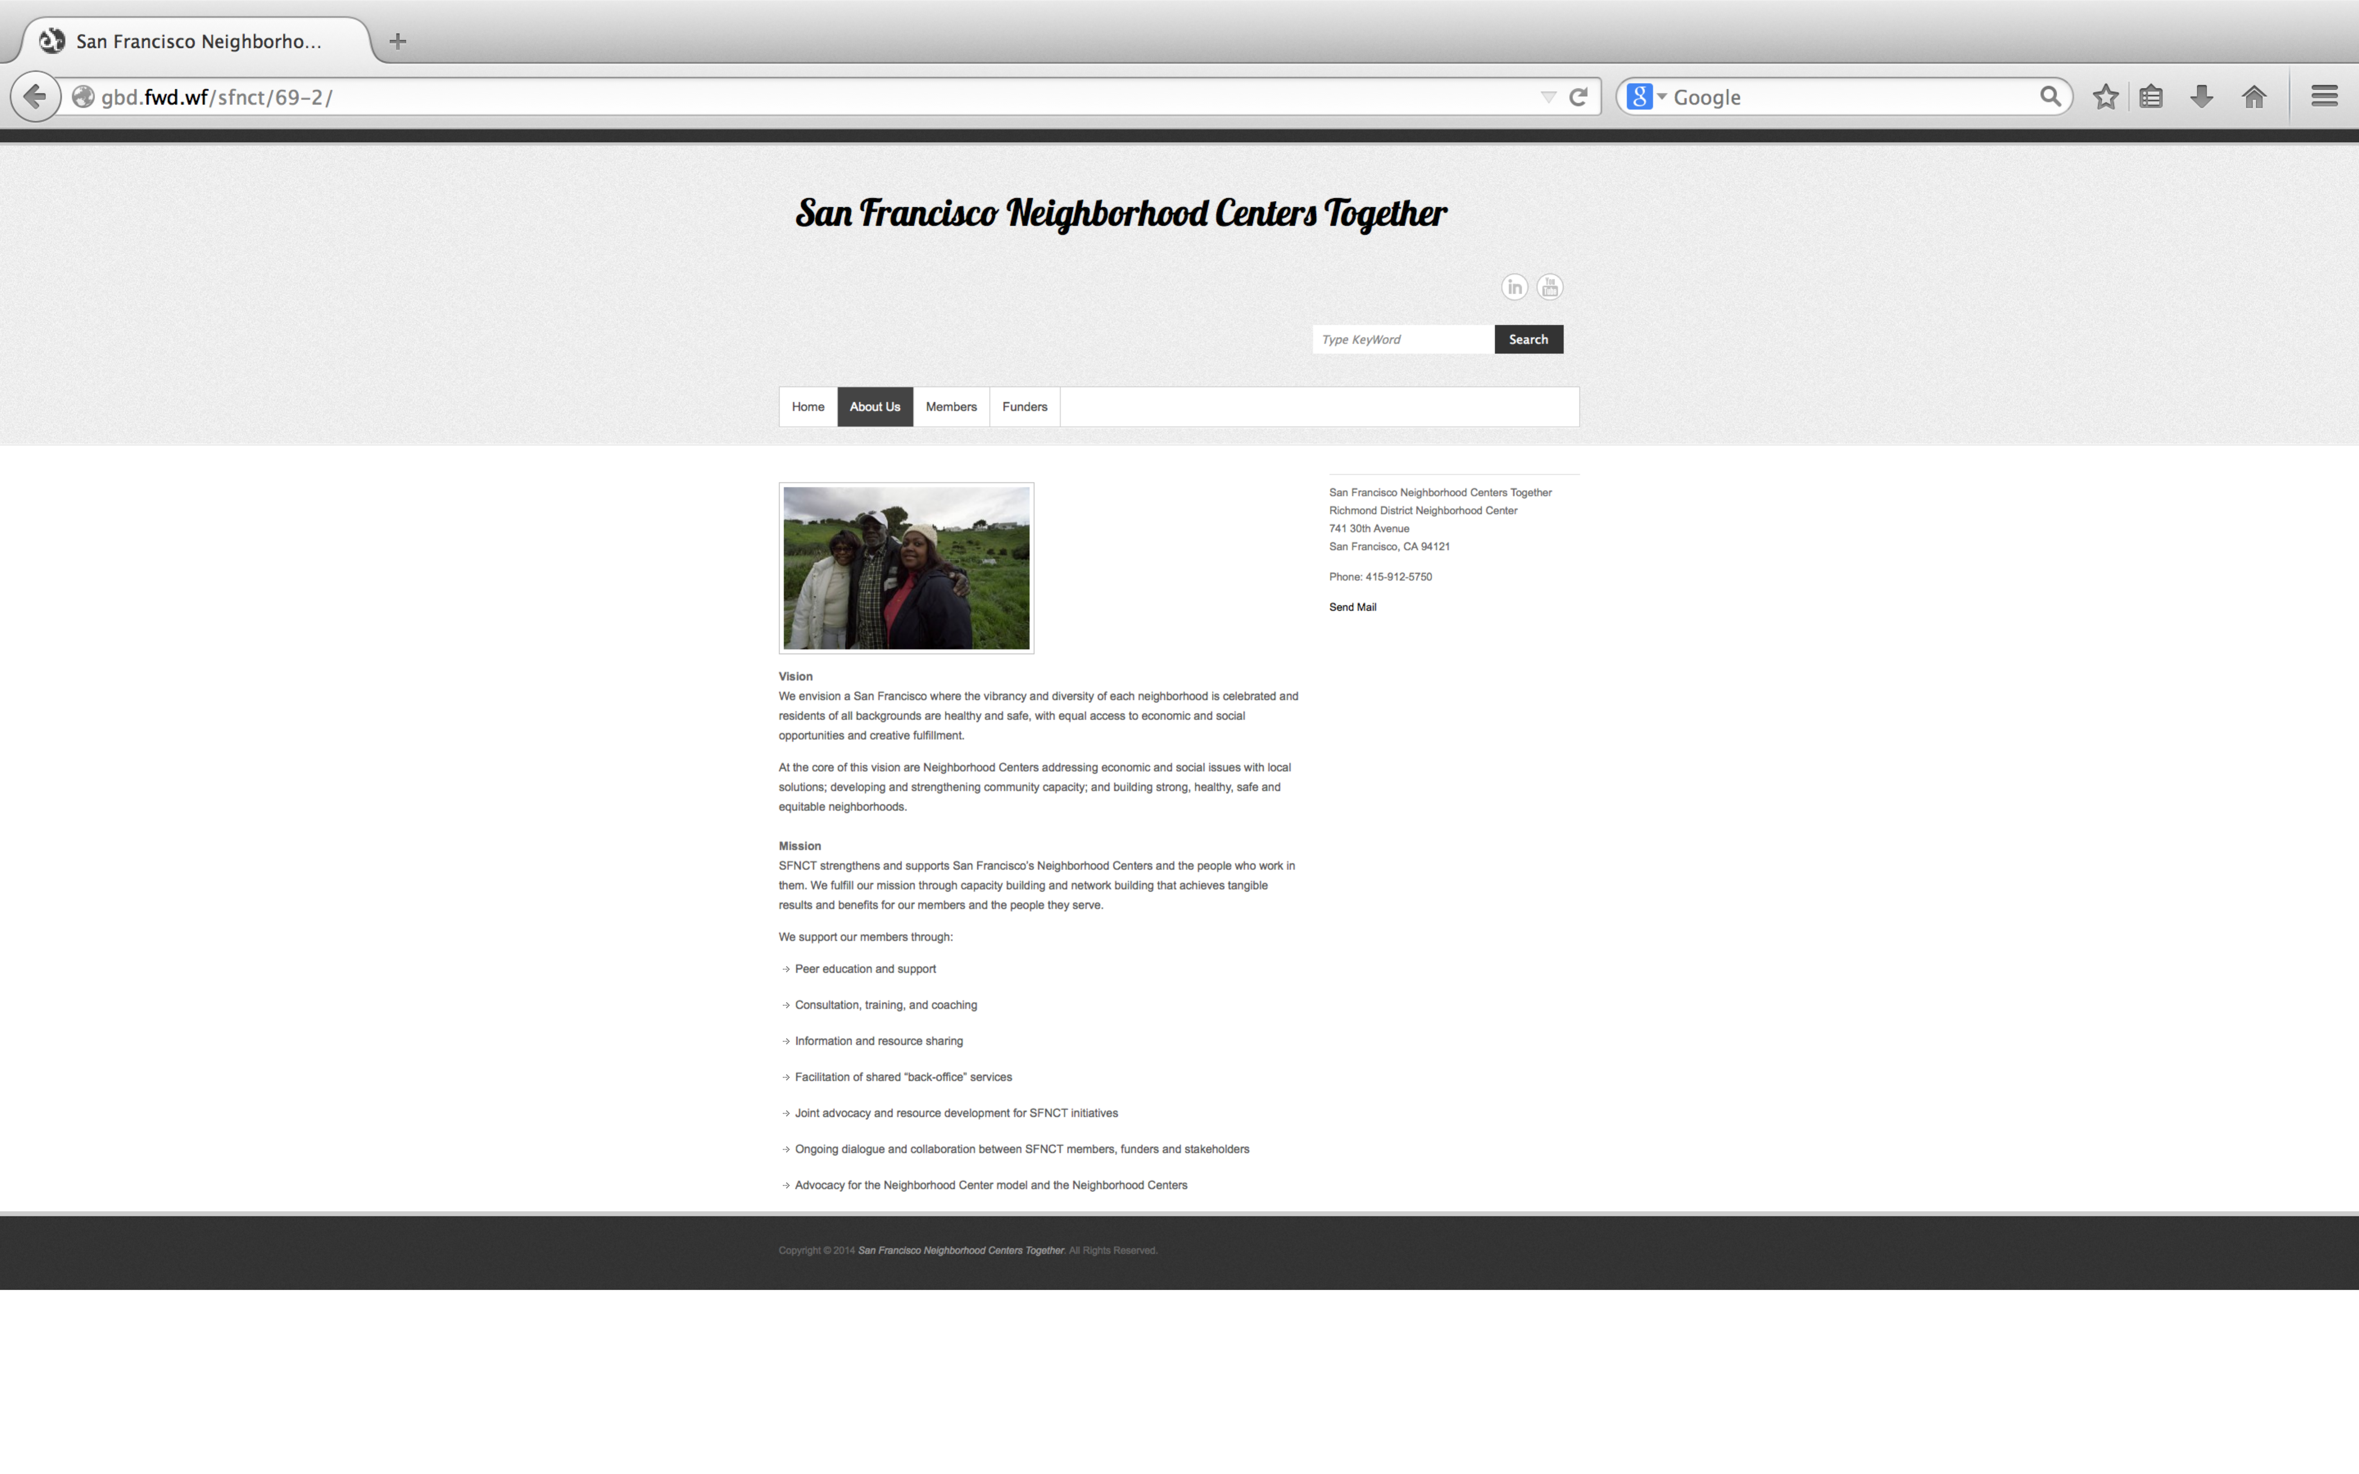

7. Select the History sub menu option will launch the About Us page to the History section on that page.

